User Manual for Trade Game

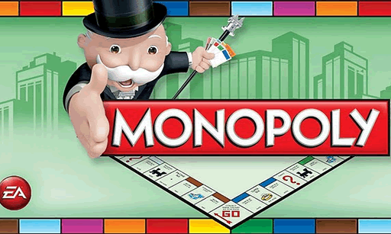

THE GAME IN BRIEF: MONOPOLY is the game of buying, renting or selling Properties so profitably that players increase their wealth – the wealthiest becoming the eventual winner. Starting from the "GO" space, move your token around the board according to your roll of the dice. When you land on a Property that is not already owned by anyone else, you may buy it from the Bank. If you do not choose to buy it, it is auctioned off to the highest bidder. Players who own Properties collect rents from opponents stopping there. The construction of Houses and Hotels greatly increases the rent you can collect, so it is wise to build on as many Sites as possible. If you need to raise more money, the Bank can give mortgages on Properties. You must always obey the instructions given on Community Chest and Chance cards. Sometimes you will be sent to Jail.

OBJECT: To be the only player left in the game who is not bankrupt.

Setup: Right after the game gets started, the player Information dialog will prompt the Banker to enter the number of players in the game. Each player is given a playing token and places it on "GO".

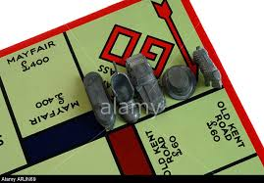

PLAYING THE GAME: On your turn, click on the roll button .Dice will be rolled and you will be moved clockwise around the board in the direction of the arrow and if you have rolled doubles, then you get one more chance to click on the roll button and you will be moved accordingly .The space you land on will determine what you have to do. Two or more tokens may rest on the same space at the same time. You may do one of the following according to the space you land on: buy Building Sites or other Properties pay rent by landing on an owned Property pay taxes draw a Chance or Community Chest card go to Jail rest on the Free Parking space collect £200 salary be “Just Visiting” Jail

Doubles: If you roll a double, move your token and act on the space you have landed on as usual. Roll the dice again and have another turn. If you roll a double for a third time in succession, you must immediately go straight to Jail.

     

Passing "GO": Every time you either land on or pass "GO" while moving in the direction of the arrow, you are paid £200 by the Bank. It is possible to collect £200 twice within one turn if, for example, you land on the Chance or Community Chest space immediately after "GO" and pick the card that tells you to "Advance to GO".

 



Buying Property: If you land on an unowned Property (that is, on a Property for which no other player holds the Title Deed), you have the first choice to buy it. There are three types of Property - Sites, Utilities and Stations. If you decide to buy, pay the Bank the price in money stated on that space. You will receive in exchange, as proof of ownership, that Property's Title Deed, which you must keep face up in front of you. If you decide not to buy, the Banker must immediately auction the Property for sale to the highest bidder, starting at any price that another player is willing to pay. Since you declined the option of buying at the original price, you cannot join in the bidding.

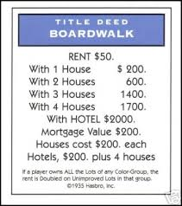 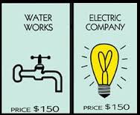 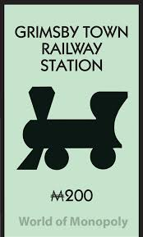

Owning Property: entitles you to collect rent from any "tenants" who land on that space. It is an advantage to own all the Sites within a color-group — in other words to own a monopoly. You can build on any Site for which you own the complete color-group.

Monopoly over Orange group:

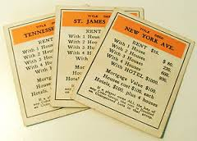 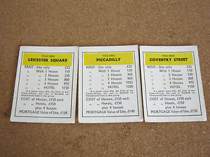

Landing on Sites: If you land on a Site that has previously been bought by another player, you may be required to pay rent for stopping there. The player who owns this Site must ask you for rent before the player following you rolls the dice. The amount payable is shown on the Title Deed for that Site and will vary according to the number of buildings on it. If all Sites within a color-group are owned by a player, the rent payable is doubled on any Site of that group not yet built on. However, an owner who owns a whole color-group may not collect double rent if any one Site there is mortgaged. Where Houses or Hotels have been built on a Site, the rent will increase and will be shown on that Site's Title Deed. Rent is not payable on mortgaged Properties.

Landing on Utilities: Landing on one of these allows you to buy the Utility if it is not already owned. As with the other Property spaces, pay the Bank the price stated on that space. If the Utility is already owned, you may be asked to pay rent to the owner according to the dice you rolled to get there. If the owner has only one of the Utilities, the rent will be four times your dice roll. If, however, both Utilities are owned by the same player, you must pay ten times the amount of your dice roll. If you decide not to buy, the Banker auctions the Utility for sale to the highest bidder.

1. If the owner owns 1 utility cell, the player pays three times the dice roll (RENT = 4\* DICE);
2. if the owner owns 2 utility cells, the player pays ten times the dice roll (RENT = 10 \* DICE);

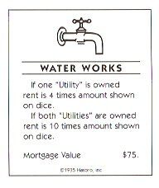 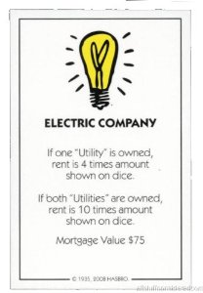

Landing on Stations: If you are the first to land here, you have the opportunity to buy the Station. Otherwise it is auctioned by the Bank; even though you declined to buy at the original price, you may join the bidding, too. If the Station is already owned when you arrive, you must pay the amount stated on the Title Deed. The amount payable will vary according to the number of other Stations owned by that player.

1. if the owner owns N railroad cells, RENT = $50 \* 2 pow(N-1);

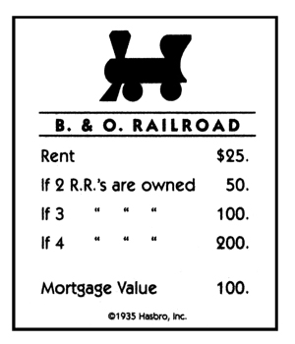 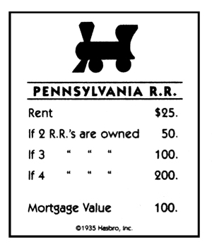 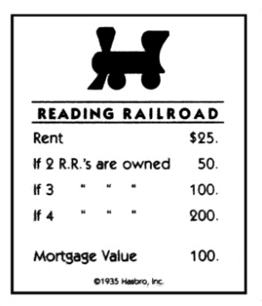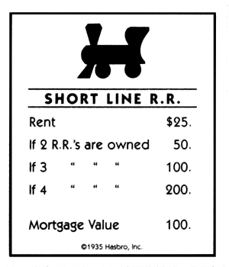

Landing on "Chance" and "Community Chest": Landing on one of these spaces means you must take the relevant card from the top of the deck.

 

These cards may ask you to:

   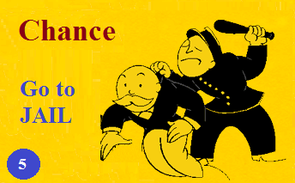 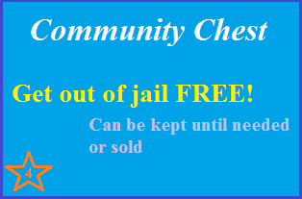

1. move your token
2. pay money – for example, in taxes
3. receive money
4. go to Jail
5. get out of Jail free.

You must follow the instructions on the card and act immediately before returning the card to the bottom of the deck. If you pick a "Get Out of Jail Free" card, you may keep it until you wish to use it or sell it at a mutually agreed price.

Note: a card may instruct you to move your token to another space. If you pass "GO" on the way, collect £200. You do not pass "GO" when you are sent to Jail, or if you are sent back.

Landing on Tax spaces: When you land on these, simply pay the relevant amount to the Bank.

 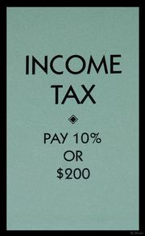

Free Parking: If you land on this space, you simply rest here until your next turn. There is no penalty for landing here: you may still undertake transactions as usual (for example, collect rent, build on Sites you own, etc.).



Jail: You will be sent to Jail if:

 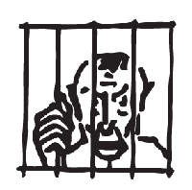

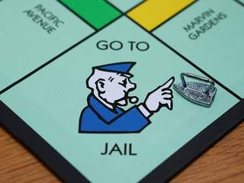 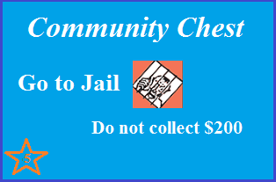 

1. you land on the "GO TO JAIL" space, or
2. you pick a Chance or Community Chest card which tells you to "GO DIRECTLY TO JAIL", or
3. you roll a double three times in succession on your turn.

Your turn ends when you are sent to Jail

IN JAIL:

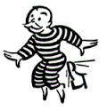 

If you are sent there, you may not collect a £200 salary, regardless of where you are on the board.

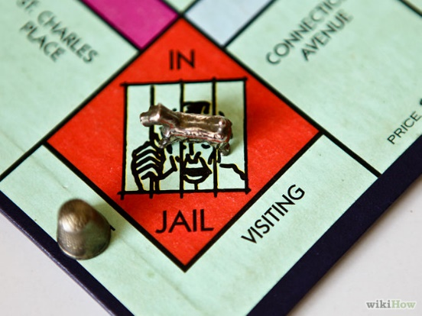

To get out of Jail you may:

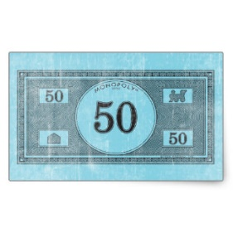

 

1. pay a fine of £50 and continue on your next turn, or
2. purchase a "Get Out Of Jail Free" card from another player at a mutually agreed price and use this to get out, or
3. use a "Get Out Of Jail Free" card if you have one, or
4. wait there for three turns, rolling the dice on each turn to try to roll a double. If you roll a double on any turn, move out of Jail using this dice roll.

After you have waited three turns, you must move out of Jail and pay £50 before moving your token according to your dice roll. While in Jail you can collect rent on Properties provided they are not mortgaged. If you are not "sent to Jail" but, during the course of play, land on the Jail space, you are "Just Visiting" and incur no penalty. On your next turn, you move ahead as usual.

Houses: Once you own all Sites of a color-group, you can buy Houses to put on any of those spaces. This increases the rent you may charge to tenants. The price of a House is shown on the relevant Title Deed. You can buy on your turn or in between other players' turns but you must build evenly: you cannot build a second House on any one Site of a color-group until you have built one House on every Site of that group, and so on up to a maximum of four Houses per Site. Selling Houses must be done evenly, too. You may buy or sell at any time, and as many buildings as your judgement and financial standing will allow. Houses may not be built if any Site of the same color-group is mortgaged. If you own all Sites of a color-group and only one or two of them have been built on, you can still collect double rent from another player who lands on one of your unimproved Sites in that color-group.

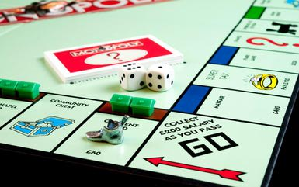 

Hotels: You must have four Houses on each Site of a complete color-group before you can buy a Hotel. Hotels are bought in the same way as Houses and cost four Houses, which are returned to the Bank, plus the price as shown on the Title Deed. Only one Hotel may be erected on any one Site.

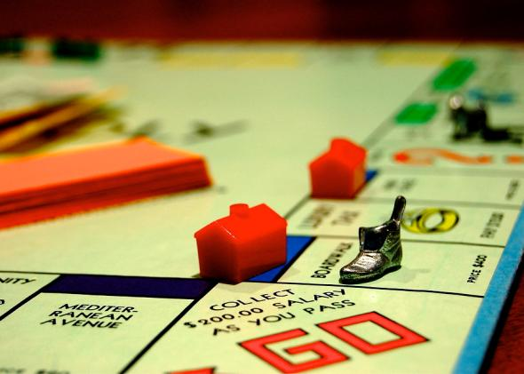

Selling Property: You may sell undeveloped Sites, Railway Stations and Utilities to any other player as a private transaction for a sum agreeable to both of you. No Site, however, may be sold to another player if any buildings stand on any of the Sites of that color-group. Should you wish to sell a Site from a color-group, you must first sell all buildings on those Sites to the Bank. Houses and Hotels cannot be sold to other players.

1. For Houses, the Bank will pay half the value stated on the relevant Title Deed. They may be sold at any time.
2. For Hotels, the Bank will pay half the cash price of the Hotel plus half the price of the four Houses which were given to the Bank for the purchase of the Hotel.

Mortgaging a Property: If mortgaging a Site, first sell any buildings to the Bank. To mortgage a Property, turn its Title Deed face down and collect from the Bank your mortgage to the value of the amount shown on the back of the card. When you wish to repay your mortgage you must pay this amount plus 10% interest. If you mortgage a Property, you retain possession of it. No other player can secure it by paying off the mortgage to the Bank. Rent cannot be collected on a mortgaged Property although it can still be collected for other Properties of that color-group.

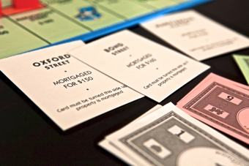

Bankruptcy: The player may be bankrupt in one of the following situations

1. Pay Rent: if player doesn’t have enough money to pay the rent, the player is bankrupt . He needs to give all tradable cells to the owner and is out of the game.
2. Draw Lose Money card: if the player cannot pay that money, the player is bankrupt.

He needs to give all tradable cells to the bank and is out of the gam

